## EXPERIMENT 6 : Use WireShark sniffer to capture network track

6.1

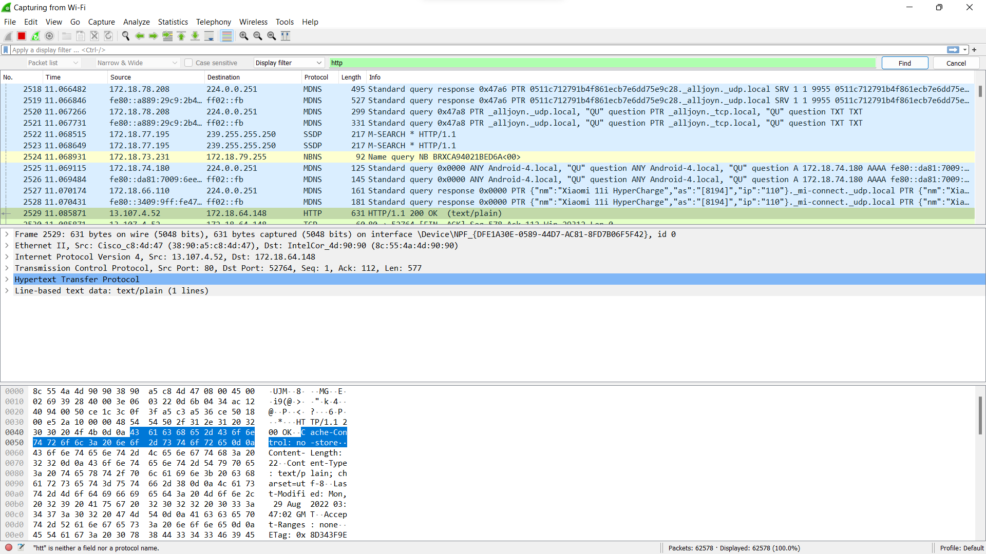

6.2